Case Study: Bank Management System
- SECTION 1: DATABASE & TABLE CREATION

1. | Create a database named bank_db
Code: | CREATE DATABASE bank_db;
Output: | 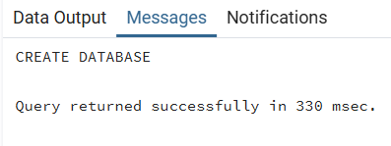
2. | Connect to the database
Code: | \c bank_db;
Output: | 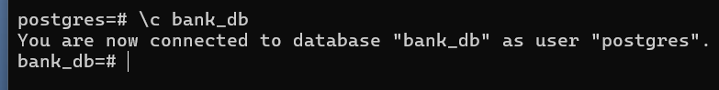
3. | Create customers table
Code: | CREATE TABLE customers (  customer_id INT PRIMARY KEY GENERATED ALWAYS AS IDENTITY,  name VARCHAR(100) NOT NULL,  email VARCHAR(100) UNIQUE,  phone_number NUMERIC(11) UNIQUE NOT NULL  );
Output: | 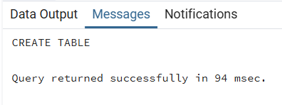  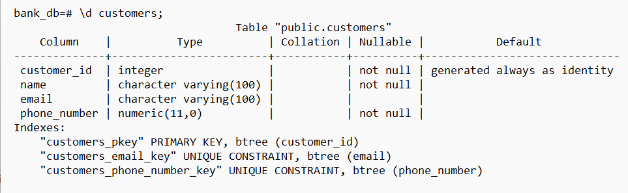
4. | Create branches table
Code: | CREATE TABLE branches (  branch_id INT PRIMARY KEY GENERATED ALWAYS AS IDENTITY,  branch_name VARCHAR(100),  city VARCHAR(100)  );
Output: | 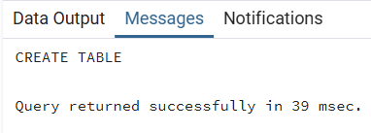  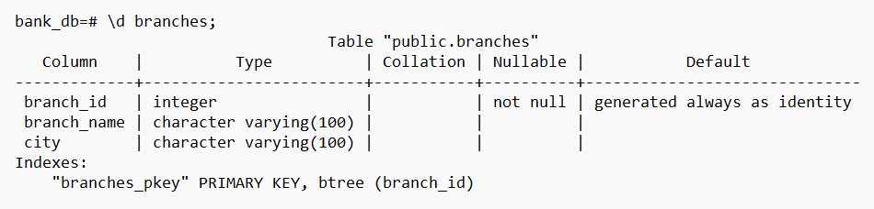
5. | Create accounts table
Code: | CREATE TABLE accounts (  account_id INT PRIMARY KEY GENERATED ALWAYS AS IDENTITY,  customer_id INT,  branch_id INT,  account_type VARCHAR(50),  balance NUMERIC(12,2),  FOREIGN KEY (customer_id) REFERENCES customers(customer_id)  );
Output: | 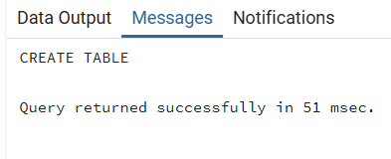  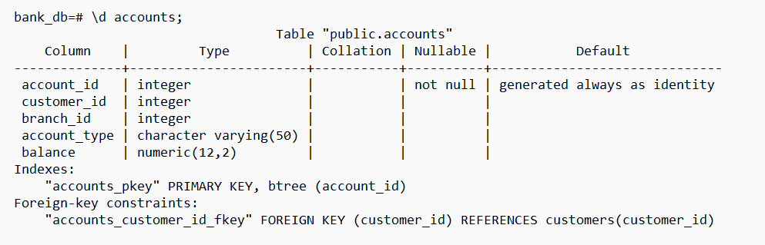
6. | Create transactions table
Code: | CREATE TABLE transactions (  transaction_id INT PRIMARY KEY GENERATED ALWAYS AS IDENTITY,  account_id INT,  amount NUMERIC(10,2),  transaction_type VARCHAR(20),  transaction_date TIMESTAMP DEFAULT CURRENT_TIMESTAMP  );
Output: | 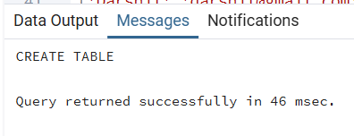  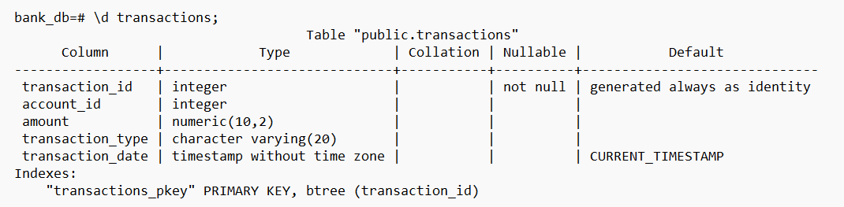
- SECTION 2: INSERT DATA

7. | Insert records into customers table
Code: | INSERT INTO customers (name, email, phone_number) VALUES  ('Darshil','darshil@gmail.com',11111111101),  ('Mehul','mehul@gmail.com',11111111102),  ('Ayush','ayush@gmail.com',11111111103),  ('Aryan','aryan@gmail.com',11111111104),  ('Ravi','ravi@gmail.com',11111111105),  ('Karan','karan@gmail.com',11111111106),  ('Jay','jay@gmail.com',11111111107),  ('Neel','neel@gmail.com',11111111108),  ('Parth','parth@gmail.com',11111111109),  ('Yash','yash@gmail.com',11111111110);
Output: | 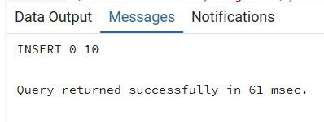
8. | Insert records into branches table
Code: | INSERT INTO branches (branch_name, city) VALUES  ('Main Branch','Ahmedabad'),  ('City Branch','Surat'),  ('Central Branch','Vadodara'),  ('North Branch','Rajkot'),  ('South Branch','Mumbai'),  ('West Branch','Pune'),  ('East Branch','Delhi'),  ('Prime Branch','Bangalore'),  ('Metro Branch','Chennai'),  ('Urban Branch','Hyderabad');
Output: | 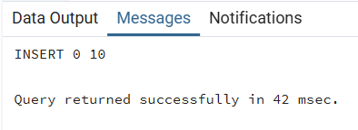
9. | Insert records into accounts table
Code: | INSERT INTO accounts (customer_id, branch_id, account_type, balance) VALUES  (1,1,'Savings',5000),  (2,2,'Current',10000),  (3,1,'Savings',8000),  (4,3,'Savings',12000),  (5,2,'Current',7000),  (6,4,'Savings',9000),  (7,5,'Current',15000),  (8,3,'Savings',6000),  (9,1,'Current',11000),  (10,2,'Savings',4000);
Output: | 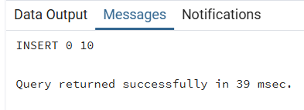
10. | Insert records into transactions table
Code: | INSERT INTO transactions (account_id, amount, transaction_type) VALUES  (1,1000,'Deposit'),  (1,500,'Withdraw'),  (2,2000,'Deposit'),  (3,1000,'Withdraw'),  (4,3000,'Deposit'),  (5,1500,'Withdraw'),  (6,2000,'Deposit'),  (7,5000,'Deposit'),  (8,1000,'Withdraw'),  (9,2500,'Deposit'),  (10,500,'Withdraw'),  (3,2000,'Deposit'),  (2,1000,'Withdraw'),  (4,1500,'Withdraw'),  (6,3000,'Deposit');
Output: | 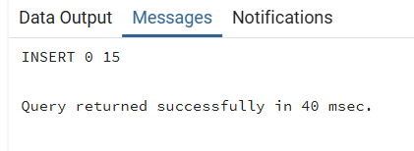
11. | Display inserted data from all tables
Code: | SELECT * FROM customers;  SELECT * FROM branches;  SELECT * FROM accounts;  SELECT * FROM transactions;
Output: | 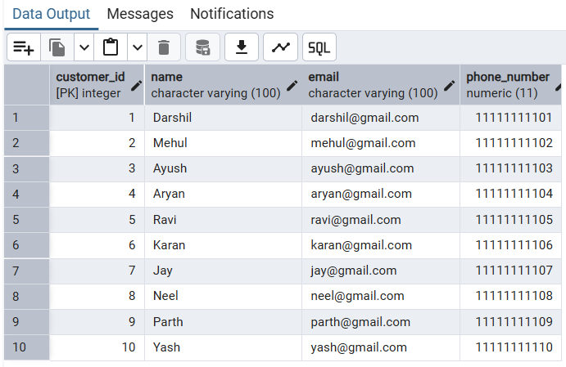  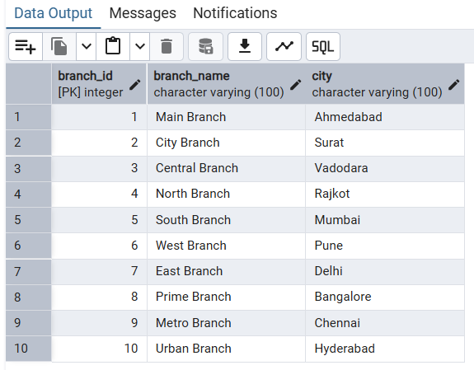  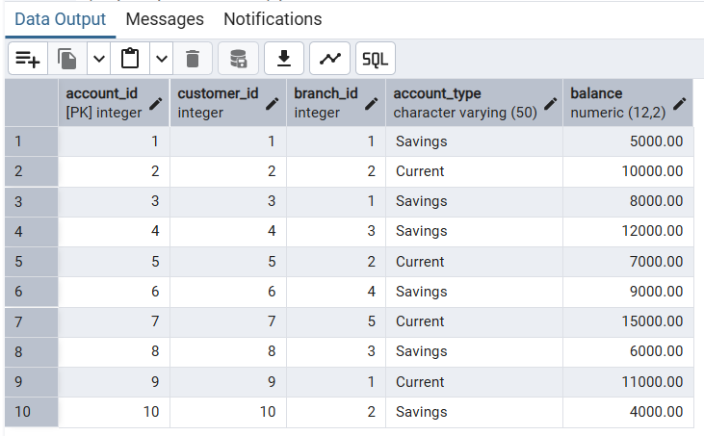  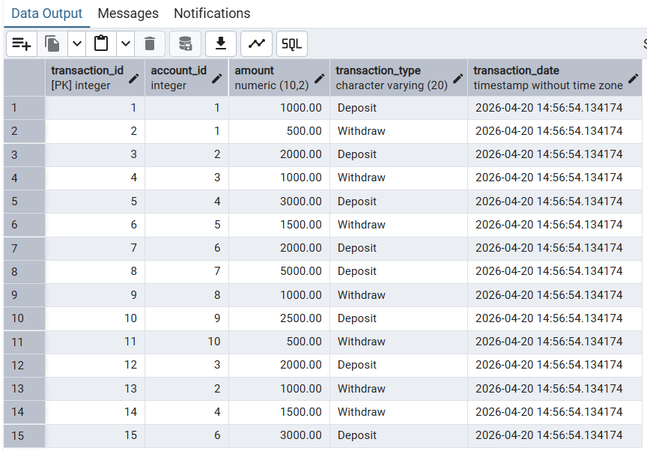
- SECTION 3: BASIC DATA RETRIEVAL

12. | Retrieve all customers
Code: | SELECT * FROM customers;
Output: | 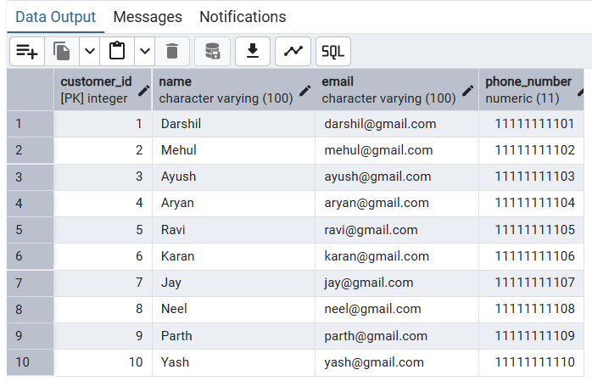
13. | Retrieve name and balance where balance > 7000
Code: | SELECT c.name, a.balance  FROM customers c  JOIN accounts a ON c.customer_id = a.customer_id  WHERE a.balance > 7000;
Output: | 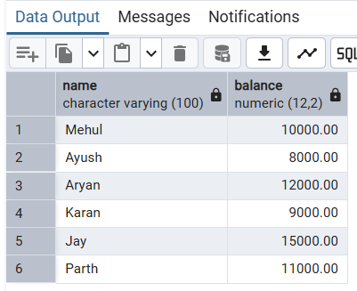
14. | Sort customers by name in descending order
Code: | SELECT * FROM customers  ORDER BY name DESC;
Output: | 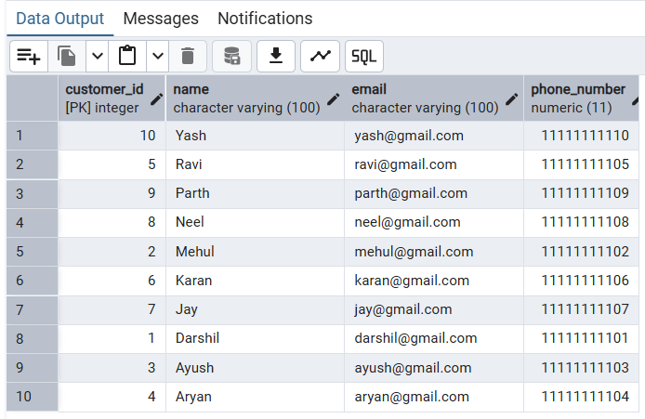
15. | Display first 5 customers
Code: | SELECT * FROM customers  LIMIT 5;
Output: | 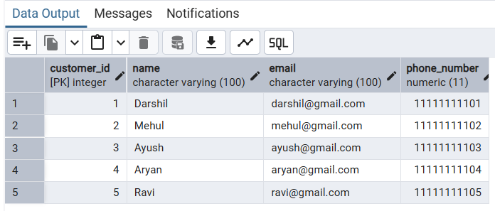
16. | Display next 5 customers (OFFSET)
Code: | SELECT * FROM customers  LIMIT 5 OFFSET 5;
Output: | 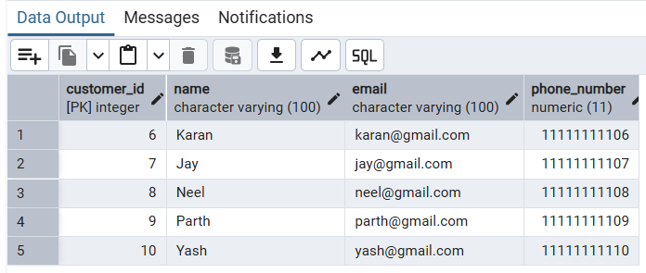
17. | Retrieve customers whose name starts with 'A'
Code: | SELECT * FROM customers  WHERE name LIKE 'A%';
Output: | 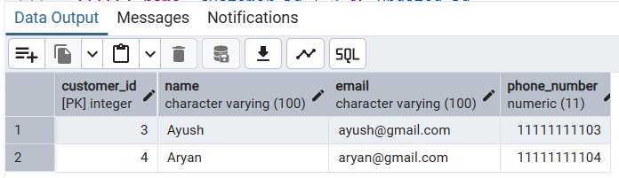
18. | Retrieve distinct branch IDs
Code: | SELECT DISTINCT branch_id FROM accounts;
Output: | 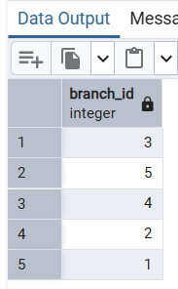
19. | Display names using alias
Code: | SELECT name AS customer_name FROM customers;
Output: | 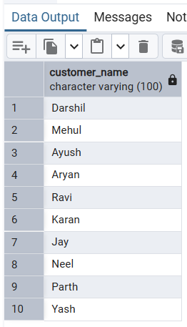
20. | Display name and updated ID (+2)
Code: | SELECT name, customer_id + 2 AS updated_id  FROM customers;
Output: | 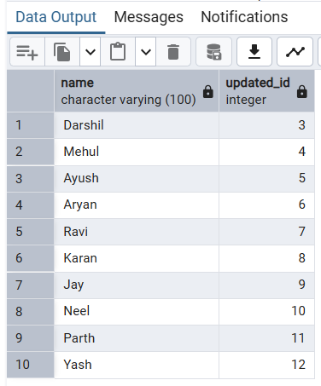
21. | Display length of each customer name
Code: | SELECT name, LENGTH(name)  FROM customers;
Output: | 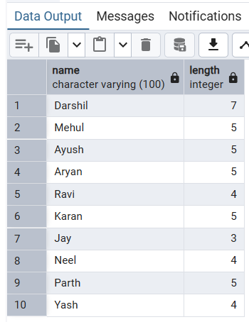
- SECTION 4: JOIN OPERATIONS

22. | INNER JOIN customers and accounts
Code: | SELECT c.name, a.account_type, a.balance  FROM customers c  INNER JOIN accounts a  ON c.customer_id = a.customer_id;
Output: | 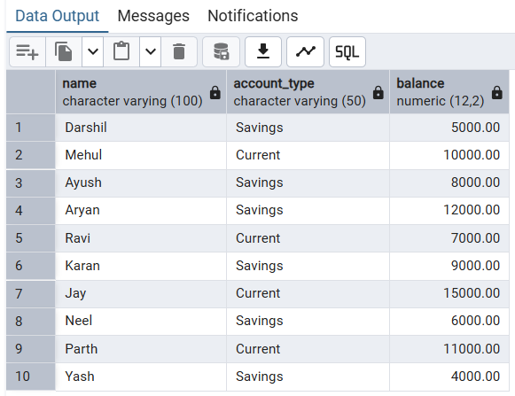
23. | LEFT JOIN (all customers)
Code: | SELECT c.name, a.balance  FROM customers c  LEFT JOIN accounts a  ON c.customer_id = a.customer_id;
Output: | 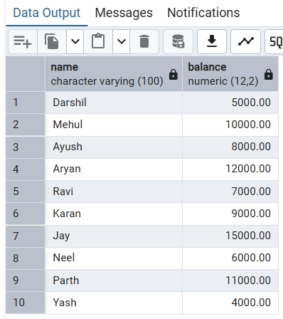
24. | RIGHT JOIN
Code: | SELECT c.name, a.balance  FROM customers c  RIGHT JOIN accounts a  ON c.customer_id = a.customer_id;
Output: | 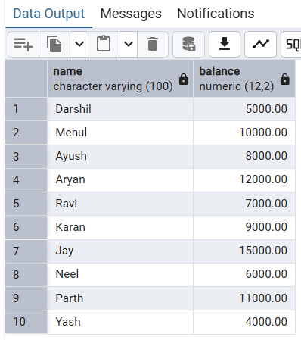
25. | FULL JOIN
Code: | SELECT c.name, a.balance  FROM customers c  FULL JOIN accounts a  ON c.customer_id = a.customer_id;
Output: | 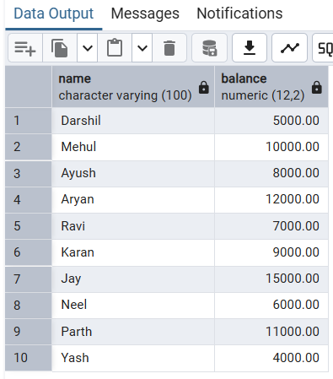
- SECTION 5: GROUP BY & HAVING
26. | Total balance per customer
Code: | SELECT customer_id, SUM(balance) AS total_balance  FROM accounts  GROUP BY customer_id;
Output: | 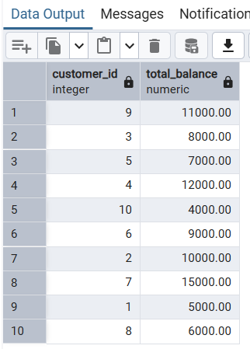
27. | Customers with total balance > 8000
Code: | SELECT customer_id, SUM(balance)  FROM accounts  GROUP BY customer_id  HAVING SUM(balance) > 8000;
Output: | 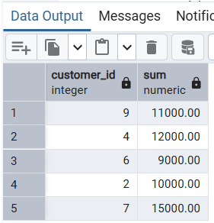
- SECTION 6: ADVANCED QUERIES

28. | Subquery (high balance customers)
Code: | SELECT name FROM customers  WHERE customer_id IN (  SELECT customer_id FROM accounts WHERE balance > 10000  );
Output: | 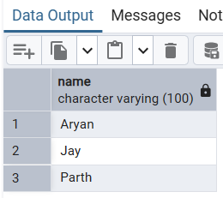
29. | Aggregate functions
Code: | SELECT COUNT(*) FROM customers;  SELECT AVG(balance) FROM accounts;  SELECT MAX(balance) FROM accounts;  SELECT MIN(balance) FROM accounts;
Output: | 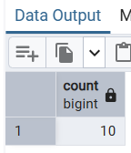  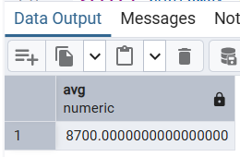  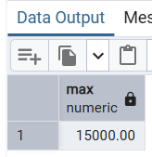  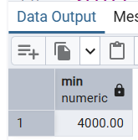
- SECTION 7: SET OPERATIONS

30. | UNION
Code: | SELECT customer_id FROM customers  UNION  SELECT customer_id FROM accounts;
Output: | 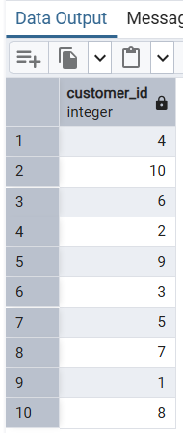
31. | INTERSECT
Code: | SELECT customer_id FROM customers  INTERSECT  SELECT customer_id FROM accounts;
Output: | 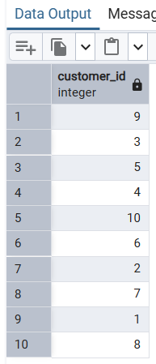
32. | EXCEPT
Code: | SELECT customer_id FROM customers  EXCEPT  SELECT customer_id FROM accounts;
Output: | 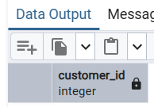
- SECTION 8: UPDATE & DELETE

33. |  | Update account balance
Code: |  | UPDATE accounts  SET balance = balance + 2000  WHERE account_id = 1;  SELECT * FROM acoounts;
Output: |  | 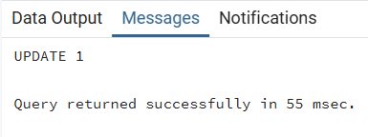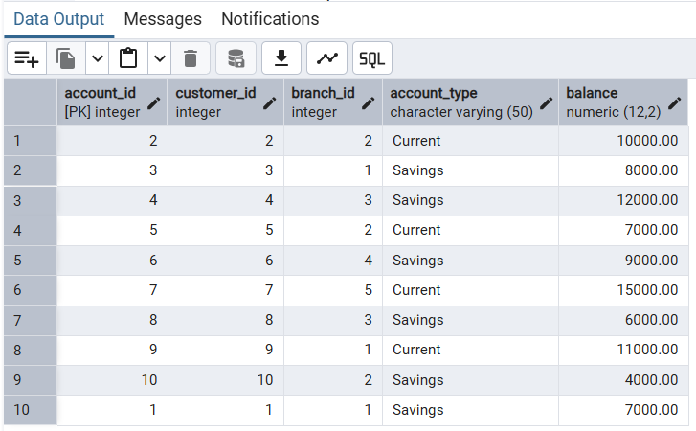
34. |  | Delete a transaction
Code: |  | DELETE FROM transactions  WHERE transaction_id = 5;  SELECT * FROM transactions;
Output: |  | 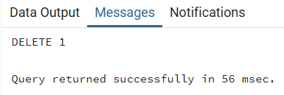  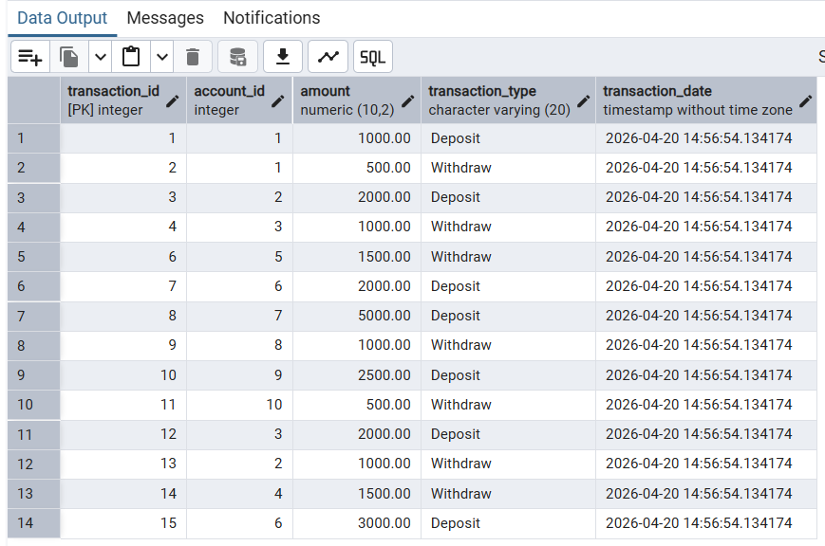
- SECTION 9: DATE FUNCTIONS

35. | Display current date and timestamp
Code: | SELECT CURRENT_DATE, CURRENT_TIMESTAMP;
Output: | 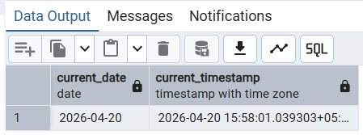
36. | Extract year from transaction date
Code: | SELECT EXTRACT(YEAR FROM transaction_date)  FROM transactions;
Output: | 